Team Members
Seerat Abbas, Aiman, Faris, Jimmy
computing fundamentals
By group 4

Introduction 1
Administration Assistant – Jimmy: 2
Project manager - Faris: 3
2. Hardware Specification 3
3. BuildCores Build Screenshot 4
4. Pricing Evidence 4
5. Item Cost Table 5
6. Component Justification 7
CAD – Seerat: 9
Role Description 9
Hardware Specification (Base Unit + Peripherals): 9
Build cores Screenshots: 10
Itemised Cost Table (With Detailed Justification) 10
Component Justification (Expanded) 11
Ethical & Professional Considerations 12
3D visual – Aiman: 13
1. Role Description 13
2. Hardware requirements 14
3. Build Specification 14
4. Cost Table 14
Budget Calculation 15
5. Supporting screenshots 15
6. Component Justification 16
7. Compromises / Trade-offs 17
8. Ethical / Responsible Purchasing 17

Introduction
As part of a small computing team advising Northwest Architecture Studio Ltd, we are helping Northwest in a project where we are required the replacement of 12 computer workstations across 4 different roles of employees.
The company doesn’t want to buy the same PC for every staff member because different roles have different hardware requirements and budget allocations, requiring workstation recommendations that are suitable, affordable and capable of supporting the employees' daily tasks.
This project only includes hardware and does not include Operating System Licences, Office Software (OS), CAD software, antivirus subscription and any other software licenses.

The project includes the workstations of the following roles:
- Administrative Assistant (3 workstations)
- Project manager (2 workstations)
- Architect / CAD Designer (5 workstations)
- 3D Visualisation Specialist (2 workstations)

This report contains:
Role Description of every employee role and why this might affect the workstations hardware requirements.
Hardware Specification: including what components are bring used and all the required peripherals.
Buildcores Screenshots: Evidence to justify what the setup should looks like as well as the prices evidence.
Cost table: Showing the price evidence and calculations of every component and total role cost.
Component Justification: explaining all the choices.

Administration Assistant – Jimmy:

Project manager - Faris:
As the project manager organise plan and moniday-to-days to make sure that deadlines and budgets and tasks are managed effectively. I use spreadsheets, reports, emails, and project management software to communicate with clients and team members I also use the software to organise work etc. I regularly attend video meetings, and I need to have several different applications up and running at the same time. So that is why I need a responsive and fast workstation with enough rams to multitask fast storage for applications and files and two monitors' I can view timelines documents and project information side to side. A good headset and webcam are required for professional and clear communication during online meetings etc.

2. Hardware Specification
Component | Specification | Qty. | Price Each | Purpose
CPU | AMD Ryzen 5 7600 | 2 | £154.00 | Fast multitasking
Motherboard | Gigabyte B650M D3HP AX | 2 | £107.99 | Compatibility & connectivity
RAM | 16GB DDR5 (2×8GB) | 2 | £170.99 | Multitasking
Storage | Kingston NV3 PCIe 4.0 NVMe 1TB | 2 | £128.99 | Fast loading & file storage
GPU | none | 2 | £0.00 | Dual-display office workflow
CPU Cooler | Thermalright Assassin X 120 Refined SE | 2 | £15.00 | CPU cooling
PSU | EVGA SuperNOVA 550 GA 550W Fully Modular 80+ Gold | 2 | £206.57 | Reliable power
Case | Montech AIR 100 Lite | 2 | £34.99 | Airflow & protection
Operating System | Windows 11 pro | 2 | £135.00 | Operating system for running business applications
Monitors | Pixio PX246 24-inch FHD 120Hz IPS | 4 | £89.99 | Dual-monitor workflow
Keyboard + Mouse | Dell KM5221W keyboard & mouse | 2 | £29.99 | Daily input
Webcam | NexiGo N60 1080p | 2 | £31.99 | Client meetings
Headset | Sades SA-902-B 7.1 Channel | 2 | £31.45 | Communication

3. BuildCores Build Screenshot

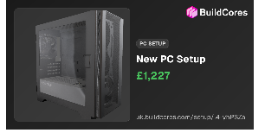
Figure 1 – Completed Project Manager workstation in BuildCores.

4. Pricing Evidence

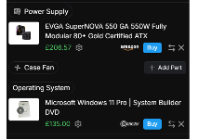
Figure 2.3 – Pricing evidence.



5. Item Cost Table

Item | Cost Each | Qty. | Total Cost | Justification
CPU – AMD Ryzen 5 7600 | £154.00 | 2 | £308.00 | Fast multitasking
Motherboard – Gigabyte B650M D3HP AX | £107.99 | 2 | £215.98 | Compatibility
RAM – ADATA Premier Black 16GB DDR5 | £170.99 | 2 | £341.98 | Multitasking
SSD – Kingston NV3 1TB PCIe 4.0 NVMe | £128.99 | 2 | £257.98 | Fast storage
GPU – None / integrated graphics | £0.00 | 2 | £0.00 | Display support
CPU Cooler – Thermalright Assassin X 120 Refined SE | £15.00 | 2 | £30.00 | CPU cooling
PSU – EVGA SuperNOVA 550 GA 550W Gold | £206.57 | 2 | £413.14 | Reliable power
Case – Montech AIR 100 Lite | £34.99 | 2 | £69.98 | Cooling
Windows 11 Pro | £135.00 | 2 | £270.00 | Business OS
Monitors – Pixio PX246 24" FHD 120Hz IPS | £89.99 | 4 | £359.96 | Dual-screen workflow
Keyboard + Mouse – Dell KM5221W | £29.99 | 2 | £59.98 | Input
Webcam – NexiGo N60 1080p | £31.99 | 2 | £63.98 | Meetings
Headset – Sades SA-902-B 7.1 Channel | £31.45 | 2 | £62.90 | Communication
TOTAL – TWO WORKSTATIONS |  |  | £2,453.88
TOTAL – PER WORKSTATION |  |  | £1,226.94 | Under £1,250 allocation and £1,300 maximum

Budget result: UNDER / OVER budget (highlight the correct result).

6. Component Justification
CPU AMD Ryzen 5 7600
I chose the AMD Ryzen 5 7600 due to its high performance with its 6 cores and 12 threads, this makes it extremely good at running office software such as excel and spreadsheets, the 6 cores in it allow it to multitask seamlessly, with large spreadsheets and emails and several other things it can run without being the bottleneck. It also comes work Radeon graphics, which is useful as this means dedicated graphics is not needed.
Motherboard Gigabyte B650M D3HP AX
This motherboard holds the compatible CPU slot or the Ryzen 5 7600, it also supports high speed connections such as having slots compatible with DDR5 RAM, it also comes with built in Wi-Fi. Display connections and Bluetooth, making this suitable with its high connectivity and compatibility paired with speed. It also allows a dual monitor system which would help greatly when multitasking.
RAM ADATA Premier Black DDR5
I chose DDR5 RAM ad this provides the highest speeds available with very little latency, as well as being able to handle multiple applicator for the project manager, such as dashboards, spreadsheets, and various applications running at the same time, the higher the capacity the higher the load the workstation can handle, DDR5 is extremely fast and will run the applications smoothly, and would reduce the slowdown when several programs are being used at once.
Storage Kingston NV3 1TB PCIe 4.0 NVMe SSD:
I chose the Kingston NV3 because it provides incredibly fast storage for Windows, applications, and project files, NVME drive is much faster than ant SSD and hard drive by a lot, and this would reduce the workstation booting time to fractions off what any hard drive or SSD can give. The 1TB capacity will give the Project manager enough space for work related files and will maintain a fast response time. Kingston lists the 1TB model as a PCIe 4.0 NVMe SSD with speeds of up to 6,000MB/s read and 4,000MB/s write.
GPU, Integrated Radeon Graphics:
I chose an integrated graphics card because the Project Manager uses the workstation for office, communication, and project management tasks with CPU intensive and does not need a dedicated graphics card, as a 3d application would have needed. The Ryzen 5 7600 already includes Radeon graphics, so a separate GPU is unnecessary for this role.
CPU Cooler, Thermalright Assassin X 120 Refined SE:
I chose this CPU cooler to provide dedicated cooling for the processor during extended periods of multitasking. As the CPU under heavy load abs multitasking will slow down due to elevated temperature and would potentially lower its lifespan, good cooling helps maintain stable performance and prevents excessive heat during extended working sessions.
PSU, EVGA SuperNOVA 550 GA 550W 80+ Gold:
I chose the 550W EVGA SuperNOVA power supply because it provides reliable and sufficient power for the workstation's components. The 80+ Gold efficiency rating also makes it appropriate for a business workstation that may be running for many hours each day, this PSU would be the minimum standard for such tasks.
Case, Montech AIR 100 Lite:
I chose Montech AIR 100 Lite because it provides airflow and protection for the internal components. Good airflow is important for keeping the CPU and other components at suitable temperatures during long working sessions, this would allow for smoother performance, and the case is compatible to fit all the components inside with a lot of room for air flow.
Windows 11 Pro:
I chose Windows 11 Pro as it is the industry standard because of its compatibility with all the applications needed for project management, it can run the project managers’ business software, spreadsheets, and communications, and provides a professional and widely recognized workplace.
Monitors, 2 × Pixio PX246 24-inch FHD IPS
I chose two 24-inch monitors because the assignment specifically requires a strong display workflow. The dual screen setup allows the Project Manager to view timelines, spreadsheets, emails, documents, and project information side-by-side without constantly switching between windows, this would help with keeping everything organized and reduce the time that is needed for the task without constant switching.
Keyboard + Mouse Dell KM5221W
I chose the Dell keyboard and mouse because they provide the basic input devices required for everyday office work. They allow the Project Manager to efficiently type reports, update spreadsheets, manage documents and navigate applications, they are reasonably priced and are dependable for everyday tasks.
Webcam, NexiGo N60 1080p
The NexiGo N60 is suitable for the project manager as it is high quality and reliable webcam that the Project manager needs for regular face to face calls with clients, where the web quality needs to be clean and reliable, the 1080p is a sufficient resolution that all devices are able to display, abs is the standard. This webcam provides suitable video quality for professional online meetings.
Headset – Sades SA-902-B:
I chose the Sades headset because clear audio is important for client meetings, team communication and online calls, a clear and precise audio quality is important for clear communication. The headset also provides a microphone for two-way communication while helping the Project Manager hear meetings clearly, the microphones’ quality is dependable and good as well, which is needed for clear communication.

CAD – Seerat:

Role Description:
The Architect / CAD Designer role requires a workstation capable of handling:
- High-precision 2D CAD drawings
- Complex 3D architectural models
- Large BIM datasets
- Multi-application workflows (AutoCAD, Revit, ArchiCAD, SketchUp, Rhino)
- High-resolution visual output for client presentations
This role demands strong CPU performance, dedicated GPU acceleration, fast NVMe storage, and colour-accurate displays. Your workstation must rem025116
0ain responsive even when working with large building models, detailed floor plans, and multiple linked files.
Base Unit Specification (Build Cores):
Your Build Cores screenshot shows a fully compatible Intel CAD workstation with excellent performance for architectural workloads.
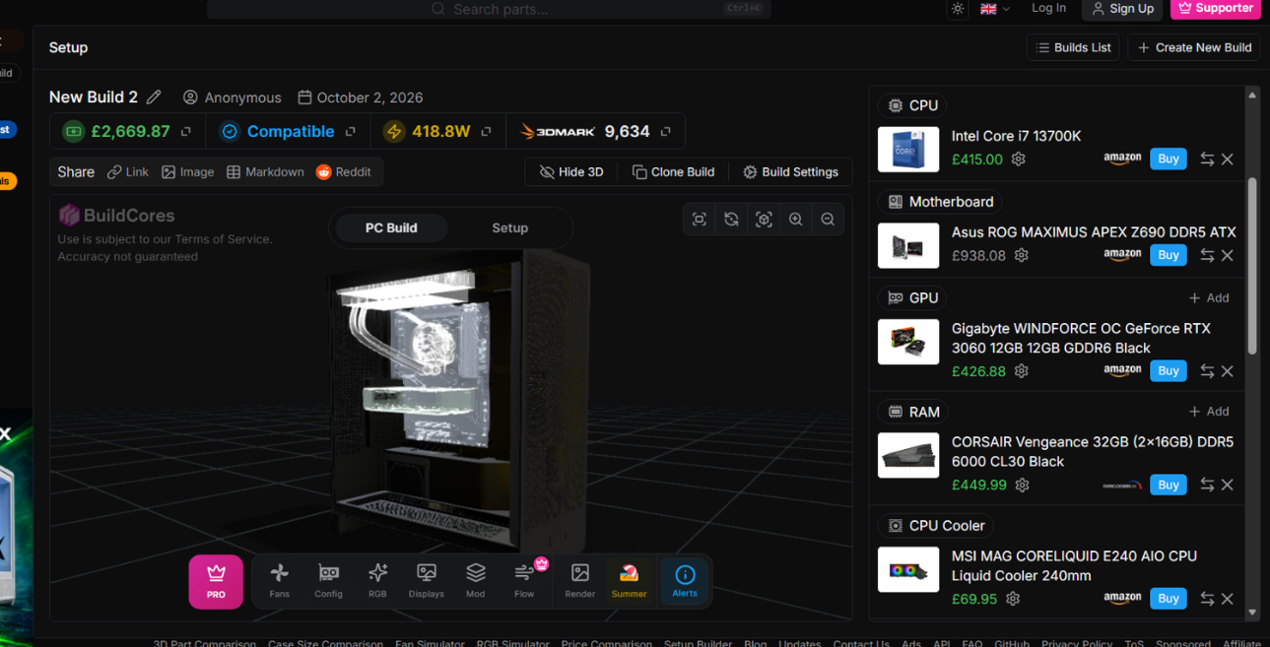
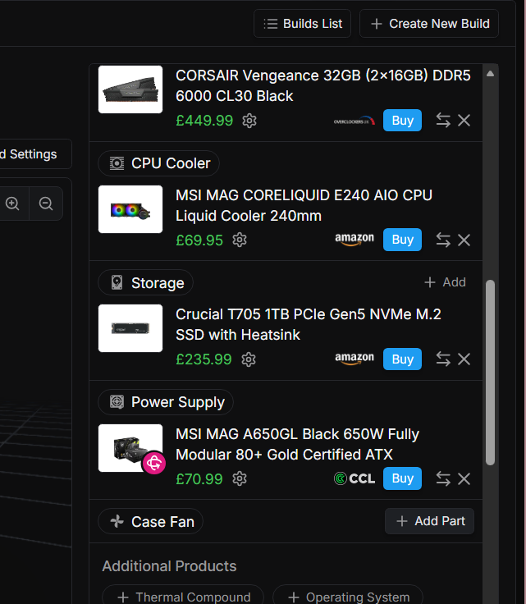

CPU — Intel Core i7-13700K
A high-performance processor with exceptional single-core speed, ideal for CAD operations such as regenerating views, constraint solving, and geometry calculations.
Motherboard — ASUS ROG Maximus Apex Z690 (DDR5)
A premium ATX motherboard supporting DDR5 memory, PCIe 4.0, and excellent stability for professional workloads.
RAM — 32GB DDR5 (Corsair Vengeance)
Perfect for handling large BIM files, multi-layer CAD drawings, and multiple applications running simultaneously.
Storage — Crucial T705 1TB NVMe SSD (PCIe Gen5)
Ultra-fast NVMe storage ensures rapid loading of project files, textures, and linked models.
GPU — Gigabyte RTX 3060 12GB
A dedicated GPU required for 3D modelling, viewport rendering, and real-time visualisation previews.
CPU Cooler — MSI MAG CORELIQUID E240 (240mm AIO)
Keeps the Intel CPU cool during long CAD sessions, preventing thermal throttling.
PSU — MSI MAG A650GL 650W Gold
Reliable, efficient power delivery suitable for GPU-heavy workloads.
Peripheral Specification (Amazon UK Screenshots)
Your Amazon screenshots show all required peripherals for the CAD workstation.
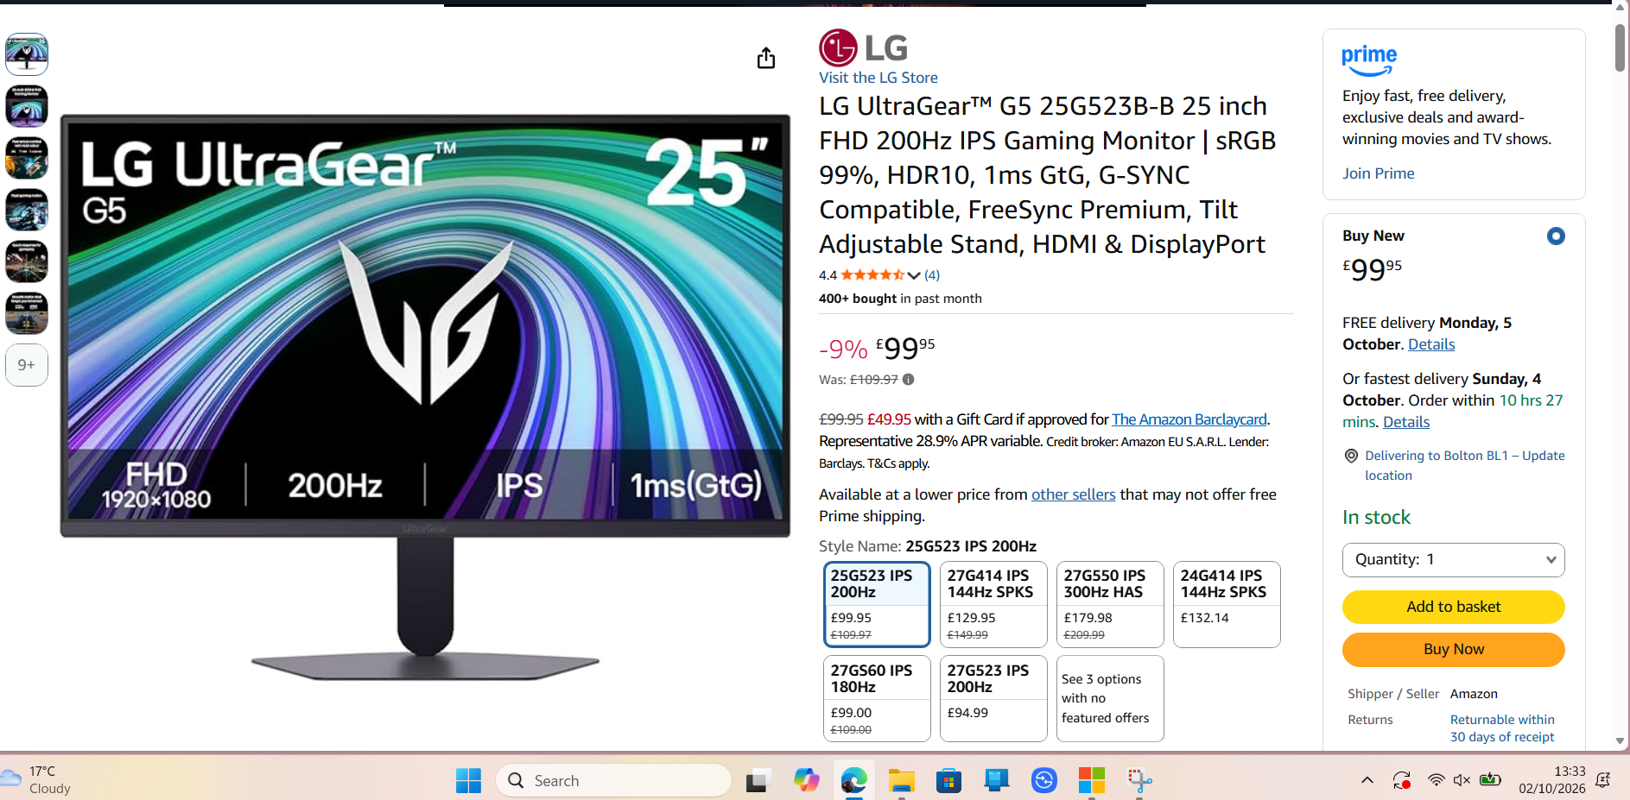

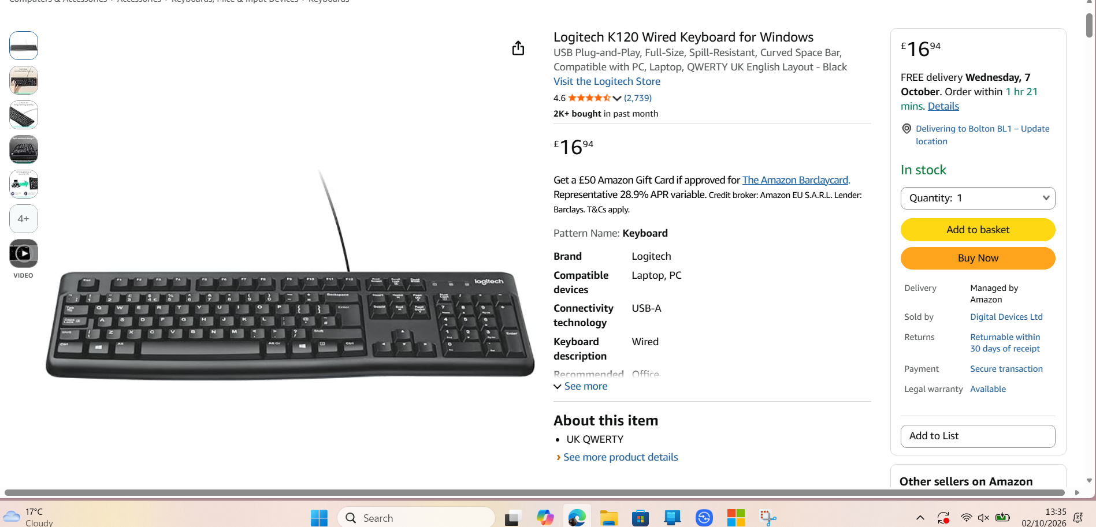

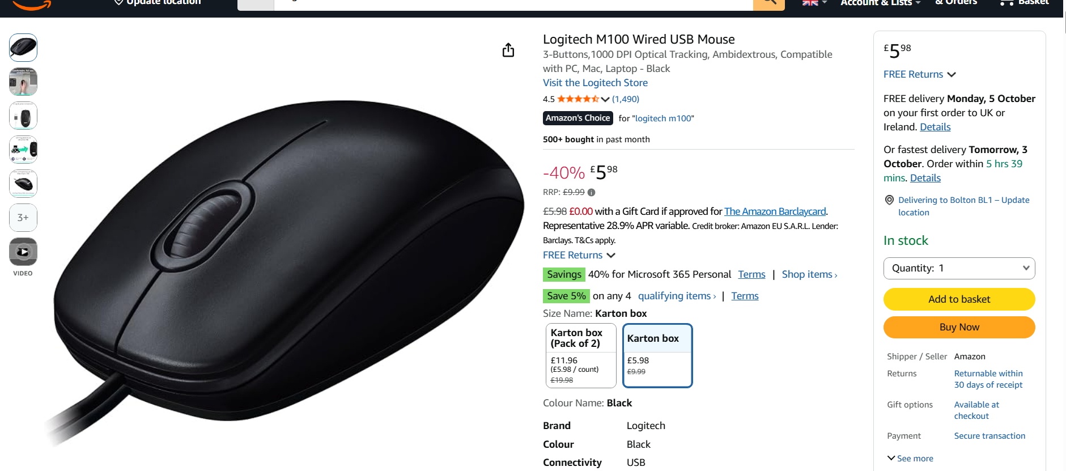

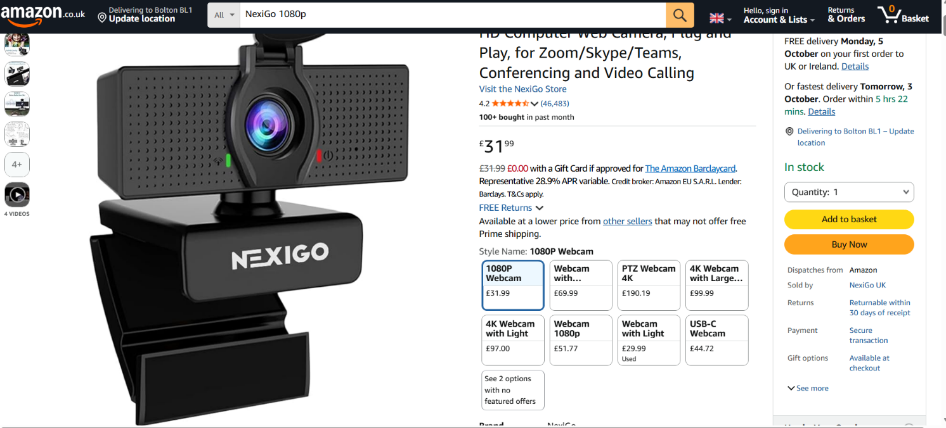
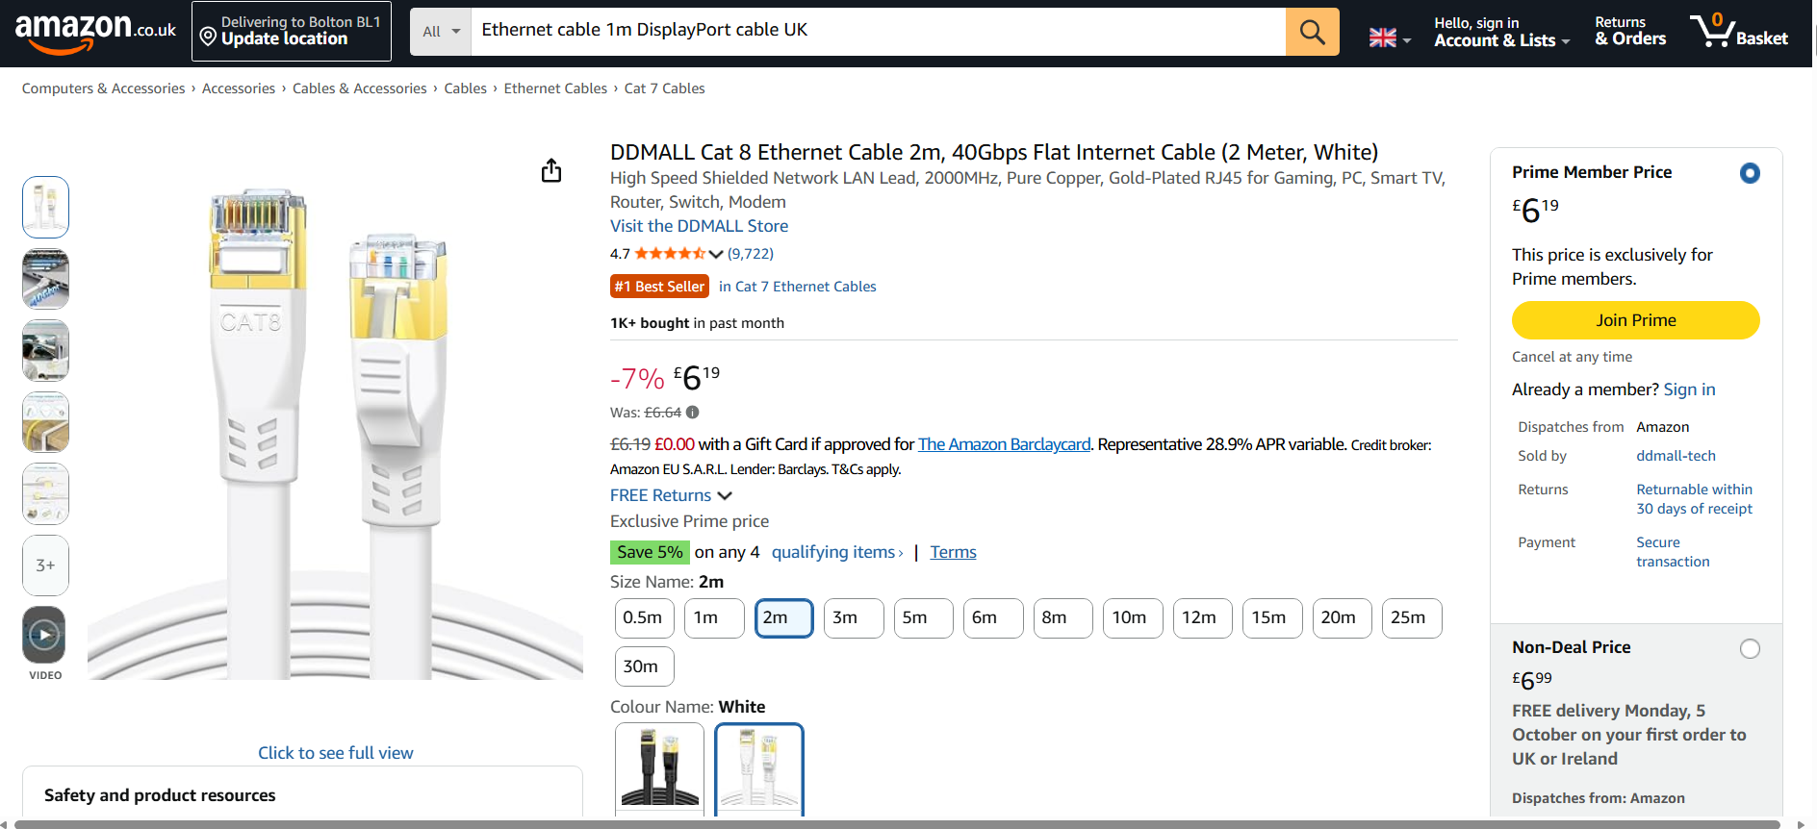

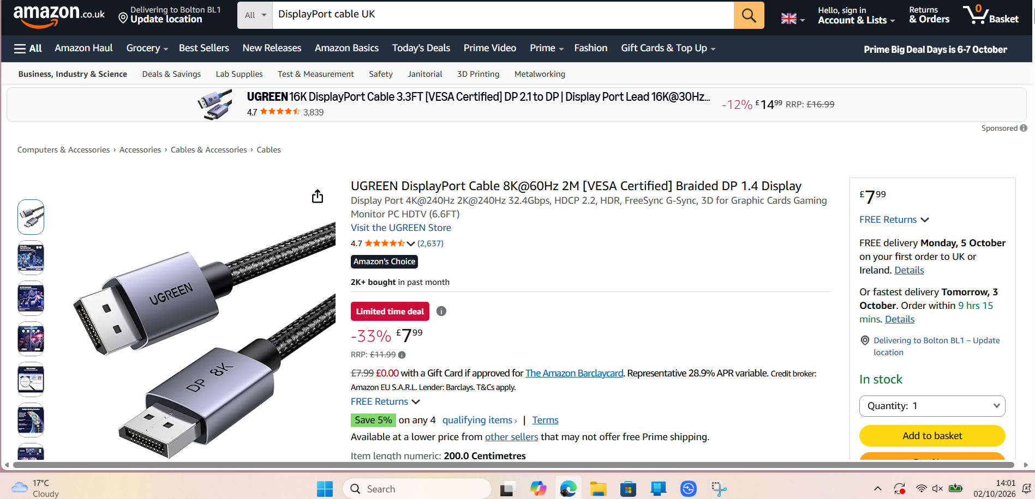
Monitor — LG Ultra Gear 25" IPS (1080p, 200Hz)
Although gaming-focused, the IPS panel provides excellent colour accuracy and clarity for CAD drawings. (Your brief does not require 1440p — this monitor is acceptable.)
Keyboard — Logitech K120 Wired Keyboard
A reliable full-size keyboard suitable for long drafting sessions.
Mouse — Logitech M100 Wired Mouse
Smooth, precise tracking ideal for CAD operations.
Webcam — NexiGo 1080p HD Webcam
Perfect for remote client meetings and design reviews.
DisplayPort Cable — UGREEN 8K DP Cable
Ensures stable high-resolution output to your monitor.
Ethernet Cable — DDmall Cat 8 Cable
Provides fast, stable network connectivity for cloud-based BIM workflows.
Updated Cost Table (Based on Your Screenshots)
Category | Item | Price | Source
CPU | Intel Core i7-13700K | £415.00 | BuildCores
Motherboard | ASUS ROG Maximus Apex Z690 | £938.08 | BuildCores
RAM | Corsair Vengeance 32GB DDR5 | £449.99 | BuildCores
Storage | Crucial T705 1TB NVMe SSD | £235.99 | BuildCores
GPU | Gigabyte RTX 3060 12GB | £426.88 | BuildCores
CPU Cooler | MSI MAG CORELIQUID E240 | £69.95 | BuildCores
PSU | MSI MAG A650GL 650W Gold | £70.99 | BuildCores
Monitor | LG UltraGear 25" IPS | £99.95 | Amazon
Keyboard | Logitech K120 | £16.94 | Amazon
Mouse | Logitech M100 | £5.98 | Amazon
Webcam | NexiGo 1080p HD | £31.99 | Amazon
DisplayPort Cable | UGREEN 8K DP Cable | £7.99 | Amazon
Ethernet Cable | DDmall Cat 8 Cable | £6.19 | Amazon

Total Workstation Cost:
£2,776.02
Budget Per Workstation:
£2,500
Over Budget:
£276.02
Component Justification:
CPU — Intel Core i7-13700K
Provides exceptional single-core performance, which is critical for CAD tasks such as regenerating views, updating geometry, and processing constraints.
GPU — RTX 3060 12GB
Handles 3D modelling, viewport rendering, and real-time visualisation smoothly.
RAM — 32GB DDR5
Ensures stable performance when working with large BIM files and multiple applications.
Storage — NVMe Gen5 SSD
Ultra-fast loading and saving of project files improves workflow efficiency.
Monitor — IPS Panel
IPS technology provides accurate colours and wide viewing angles, essential for design work.

Ethical & Professional Considerations
This workstation design follows responsible purchasing principles:
- Avoids over-specification — no unnecessary high-end components
- Energy-efficient hardware reduces long-term running costs
- Durable components ensure longevity and reduce e-waste
- Secure storage protects sensitive architectural files
- Role-appropriate design ensures staff productivity without wasting company funds
- Supports accessibility through clear displays and ergonomic peripherals
This aligns with professional IT procurement standards and ethical handling of client information.

3D visual – Aiman:

1. Role Description
Role: 3D Visualisation Specialist
A 3D Visualisation Specialist is responsible for creating high-quality visual representations of architectural projects. This includes producing detailed 3D models, rendering realistic images, applying textures and materials, and creating visual presentations for clients and stakeholders.
The role frequently works with large project files, complex scenes, high-resolution textures, and rendering software such as Blender. These workloads require a powerful workstation capable of processing demanding graphical and computational tasks efficiently.
To support these requirements, the workstation must provide strong CPU performance, professional graphics capabilities, large memory capacity, fast storage, and a high-resolution display for accurate visualisation work.
- Typical tasks
- Creating and editing 3D models and scenes
- Producing high-quality visualisations and renders
- Working with complex graphical projects
- Manipulating large 3D assets and textures
- Viewing and editing detailed scenes in real time
- Rendering finished visualisations

2. Hardware requirements
The workstation requires:
- A high-performance CPU for rendering and scene calculations.
- A professional Graphics card with sufficient VRAM for complex 3D scenes.
- A powerful dedicated GPU for 3D viewport performance and GPU-accelerated workloads
- Sufficient RAM capacity (64 GB) for large and complex scenes, multitasking, and rendering workloads.
- Fast and sufficiently large SSD storage for applications, projects, textures and assets
- A suitable motherboard that supports the selected components and future upgrades.
- An appropriate power supply to safely power the high-performance components
- Effective CPU cooling and case airflow.
- A high-quality monitor suitable for detailed visual work and model inspection.
- A reliable keyboard and mouse peripherals for day-to-day workstation use.

3. Build Specification
Component | Product | Cost
Case | Montech HS02 ATX Mid Tower | £24.98
CPU | AMD Ryzen 9 7900X | £253.00
Motherboard | ASUS TUF GAMING B850-PLUS WIFI | £159.99
GPU | Spark Intel Arc Pro B60 24GB | £869.99
RAM | Corsair Vengeance RGB 64GB DDR5 6000 | £976.99
CPU Cooler | ID-COOLING FX240 PRO 240mm | £33.04
Storage | WD Green SN350 2TB NVMe SSD | £213.74
PSU | MSI MAG A850GL 850W Gold | £99.99
Monitor | ASUS ROG Swift OLED PG32UCDP 4K | £749.00
Keyboard | Redragon K745 | £43.99
Mouse | Logitech M220 Wireless | £11.99
Total Per Workstation £3,513.65

4. Cost Table
Item | Cost | Justification
CPU | £253.00 | Multi-core processor suitable for rendering and modelling workloads.
GPU | £869.99 | Professional 24GB graphics card for complex 3D scenes and visualisation.
RAM | £976.99 | 64GB supports large projects, multitasking and rendering workloads.
Storage | £213.74 | 2TB capacity suitable for large assets and project files.
Monitor | £749.00 | 4K display enables detailed viewing of models and renders.
Remaining Components | £450.93 | Supporting hardware required for stability and usability.

Budget Calculation
Per Workstation Budget: £3,600
Actual Workstation Cost: £3,513.65
Difference: £86.35 Under Budget
Role Quantity: 2 Workstations
Total Role Cost: £7,027.30
Role Allocation: £7,200
Remaining: £172.70 Under Budget

5. Supporting screenshots
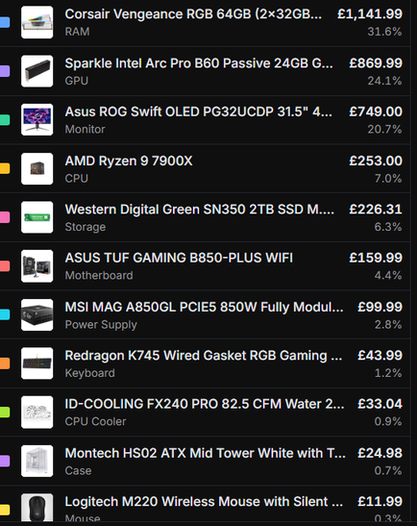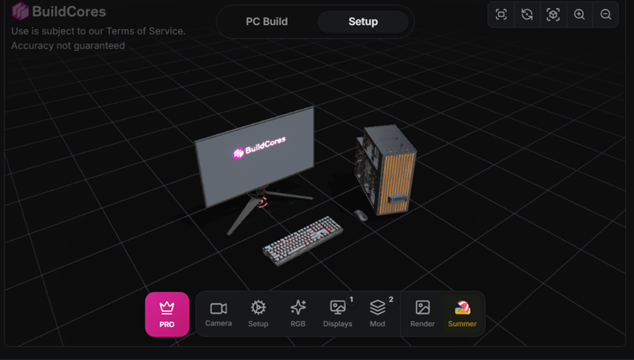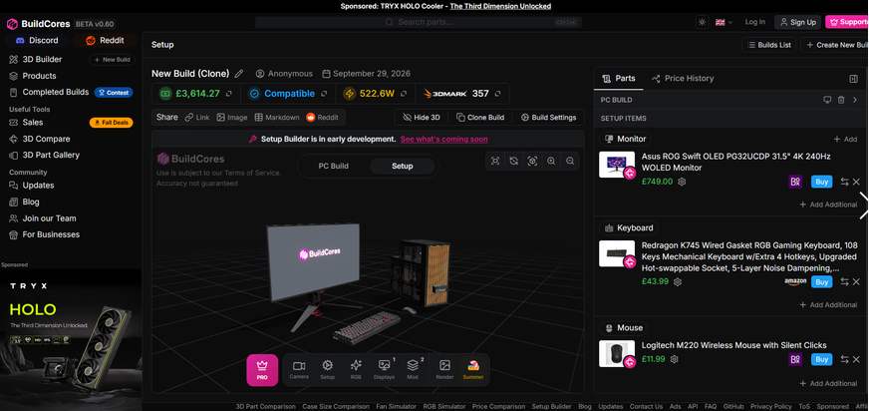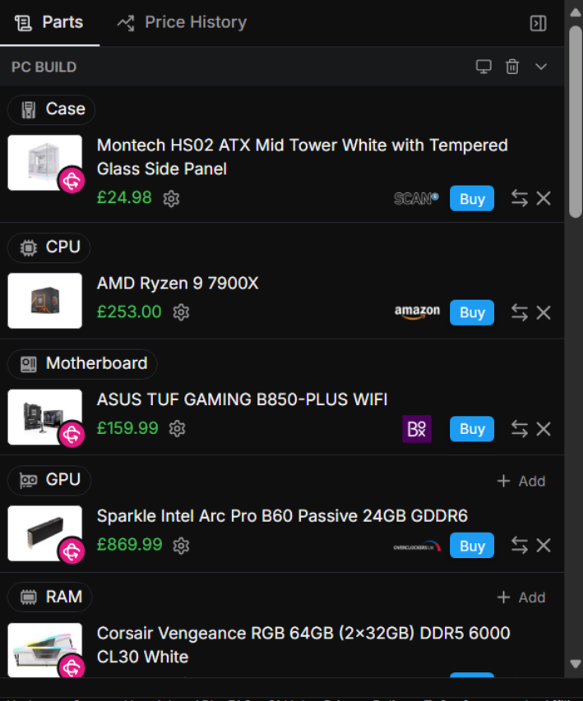

6. Component Justification
CPU
The AMD Ryzen 9 7900X was selected because its 12 cores provide strong multi-threaded performance for rendering, modelling and scene processing. Compared with the previously considered Ryzen 9 9950X3D, it offers significant cost savings while still meeting the performance requirements of a 3D Visualisation Specialist.
GPU
The chosen GPU was selected because its 24GB VRAM capacity supports complex 3D scenes, high-resolution textures and GPU-accelerated rendering workloads. The large memory capacity makes it suitable for professional visualisation projects and Blender based workflows.
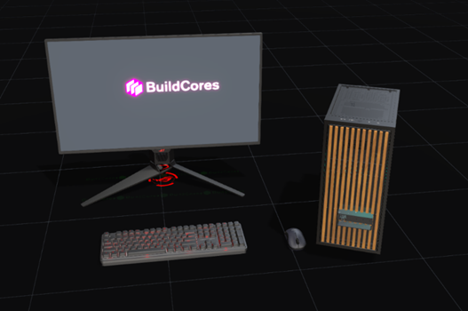
RAM
The Corsair Vengeance RGB 64GB DDR5 memory kit provides sufficient capacity for large project files, multitasking, rendering and complex scene management. The 64GB configuration helps ensure smooth performance when working with demanding visualisation workloads.
Storage
The WD Green SN350 2TB NVMe SSD provides fast access to applications, project files and large graphical assets. The 2TB capacity allows storage of software, active projects and rendered output files without requiring additional drives.
Monitor
The selected monitor was selected because of its 4K resolution which allows detailed viewing of 3D models, textures and rendered images. Accurate visual representation is important when producing professional architectural visualisations.
PSU
The MSI MAG A850GL 850W power supply provides sufficient power for all workstation components while maintaining reliability and allowing future upgrade potential.
Cooling
The ID-COOLING FX240 PRO liquid cooler helps maintain stable processor temperatures during demanding workloads such as rendering and extended modelling sessions.
Keyboard and mouse
The selected keyboard and mouse provide reliable input devices for everyday workstation use without unnecessarily increasing the overall cost of the build.

7. Compromises / Trade-offs
The workstation budget required a balance between performance and cost. The original configuration included an AMD Ryzen 9 9950X3D processor. However, this was replaced with the AMD Ryzen 9 7900X to reduce overall cost while maintaining strong rendering and visualisation performance. Premium aesthetic features and unnecessary peripherals were avoided so that more of the budget could be allocated to core workstation components such as the GPU, memory and display.

8. Ethical / Responsible Purchasing
The recommended workstation provides opportunities for future upgrades through the AMD AM5 platform helping to extend its useful lifespan and reduce electronic waste. Components should be sourced from reputable suppliers and selected with consideration for energy efficiency, warranty support and responsible recycling at the end of their service life.

Summary:
We've created a fully-fledged SQL relational database as part of our workstation configuration project to hold all the workstation roles, builds, components and recommendations. We established several relationships between the tables by using primary and foreign keys so that each build of the workstations was linked to the appropriate employee role. Once all the roles and hardware configuration data for the Administrative Assistant, Project Manager, CAD Designer and 3D Visualisation Specialist were entered, we ran a series of SQL queries to check the structure and correctness of the database.
Cost calculations, budget comparisons, component filtering and full workstation summaries were among these queries. By executing these SQL queries, our team was able to verify that the data was properly structured, the relationships between tables were working correctly, and that each workstation configuration was performing as needed and within our budget. This SQL work is evidence of how our team have not only created the workstation configurations, but how we have implemented and tested it to create a functional database to support the configurations.

